**Introduction to the drilling monitoring software: the structure, case study and machine learning**

**Han Jiang, UT petroleum engineering PhD**

**Part I. The structure of the drilling monitoring software**

Real-time drilling performance analysis is critical for drilling process assessment. Understanding the status of drilling bit is important as people often fail to trip out bits until they are totally damaged. In order to accurate assess bit conditions and predict the pulling out time, a **drilling monitoring software package Drilling-OPT** is developed, which integrates real-time data extraction, bit condition assessment and warning system.

**Drilling data extraction**

**WITSML Data:** The WITSML is a XML standard for transmitting technical data in the petroleum industry. The drilling WITSML data is stored though the online database. The data could be accessed by internet browser or API (Application Program Interface). Drilling-OPT software can log onto the website, redirect to the right page and download the data in LAS format. It can also use API provided by the database company: Drilling-OPT sends requests to the server and receives the JSON-based data. The JSON data then is parsed and converted to tabular data.

**Extraction:** During drilling process, the database updates its data every 10 minutes with 60 data points. Drilling-OPT will read from online database in the same frequency. Each data point contains sensor parameters. The parameters used by Drilling-OPT are: Depth, WOB (weight on bit), TPO (total pump output), TOP, RPM (round per minute), ROP, and motor information (motor size, torque vs. difference pressure).

**Filtering and metric calculation**

**1st filtering**: The retrieved sensor data will be first checked and NPT (Non-production Time) data will be filtered. This is done by setting thresholds for WOB, TPO RPM.... Filtered data will be converted to depth based data.

**Metrics:** Based on the sensor parameters, Wear Out Factor and Bit Aggressive, two bit condition metrics, are calculated. Traditionally, operator uses only ROP to guess the condition of drilling bit. Drilling-OPT defines the two metrics to enhance the bit condition assessment. Wear Out Factor is a function of WOB, motor information, ROP, RPM. The Bit Aggressive is a function of WOB, motor information.

**2nd filtering:** After calculating the metrics, a second data filtering is performed based on a 15-point window median filtering. The median filtering can better handle outliers in the raw data and reduce oscillations compared with moving average filtering.

**Bit performance assessment (Engineering approach)**

According to the historical drilling data, the increased Wear Out Factor or decreased Bit Aggressive show a good correlation with higher possibility of bit damage. A simple **engineering solution** is proposed which calculates thresholds for the two metrics using peaks from historical drilling data. Once the real-time drilling metrics cross the threshold boundary, the bit is considered as wear out.

**Visualization and warning**

After calculating metrics, Drilling-OPT uses visualization modulus to send metrics data and page layout information to the server. People can monitor the drilling performance though the website. When the software detects damage signal, it will send warning messages and emails to the on-site operators and drilling experts.

**Part II. Case study**

Recently we collaborated with an operator company to test and validate our software. The wellsite was located in Permian Basin. The formation mainly consists of three layers. The top is a soft layer which ends around 4000ft. The middle layer ends around 6000ft. The bottom layer from 6000ft to 10000ft is the Wolfcamp layer.

By mining into the nearby 4 well data, the software separated the formation into two layers (the soft layer is neglected) and generated critical values for wear factor, ROP and Bit aggressive.

|  |  |  |  |
| --- | --- | --- | --- |
| Layer interval | Wear factor | ROP(ft/hr) | Bit aggressive |
| 0-6000ft | >100 | <60 | <0.2 |
| 6000ft | >80 | <60 | <0.2 |

**First Bit**

**Normal operation**: below is the snapshot from Depth 1000-3000ft (Figure 1). The columns from left to right are Wear Out Factor, ROP and Bit Aggressive, respectively. In this section, the drilling bit penetrated through the soft layer. All three indexes looked good.

**First Pull-out**: The software sent the first warning at depth of 5250ft, where Wear Out Factor and ROP crossed their danger boundaries. It continued sending warnings in serval hours. Due to other issues, the operator, didn’t pull out the bit until depth 5430ft.

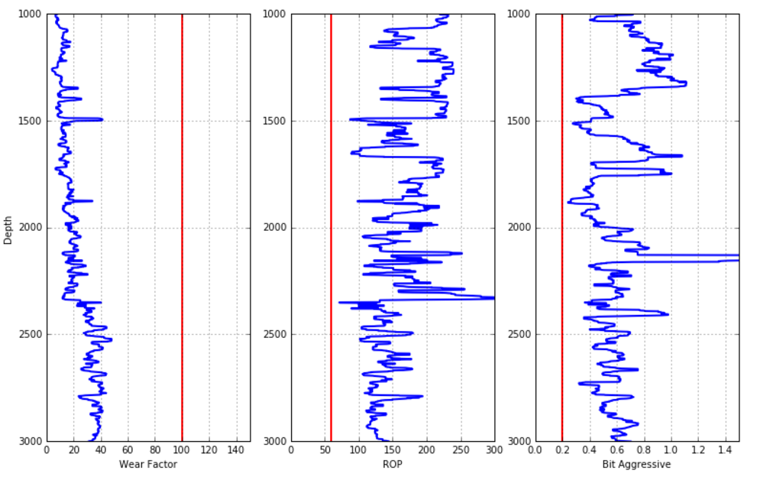

Max Wear Factor

Min ROP

Min

Bit Agg

Figure 1 the drilling process from Depth 1000-3000ft

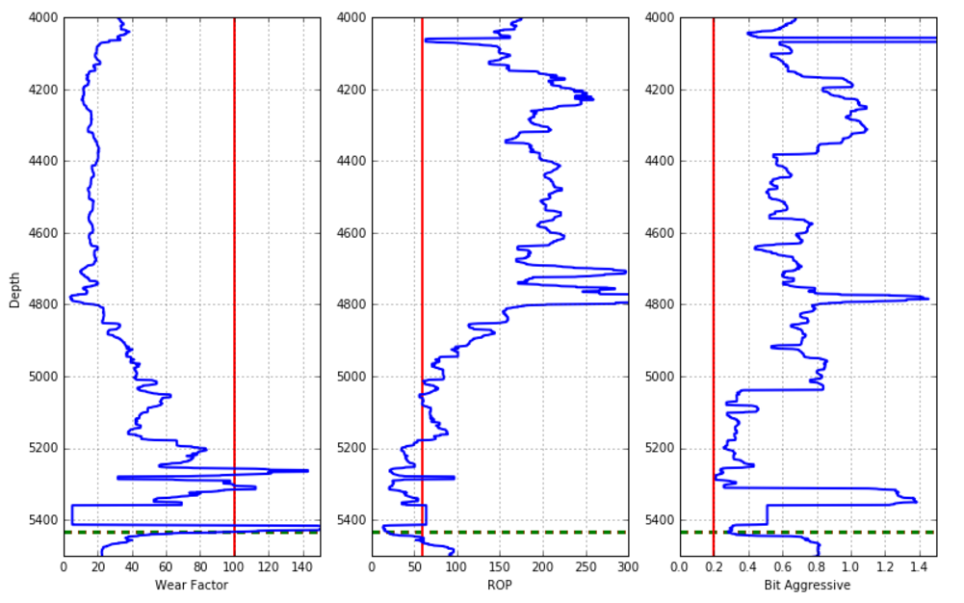

Pull-out

Figure 2 the drilling process from Depth 4000-5500ft. The green dash lines stand for the pull-out depths

**Second and third bit**

**Normal operation**: below is the snapshot from Depth 6000-8000ft (Figure 3). The bit indexes went back to normal.

**Second Pull-out**: The software sent first warning at depth of 9050ft. The Wear Out Factor and ROP crossed their danger boundaries. The operator pulled out the bit after 50ft. The pulled out bit showed that it had not been severely damaged and the pull-out was right on time.

**Third Pull-out**: The software sent first warning at depth of 9250ft. It continued sending warnings. The operator kept drilling and pulled out the bit at end depth of 9500ft. The bit was damaged, and the relative short lift time was due to extreme hard rock.

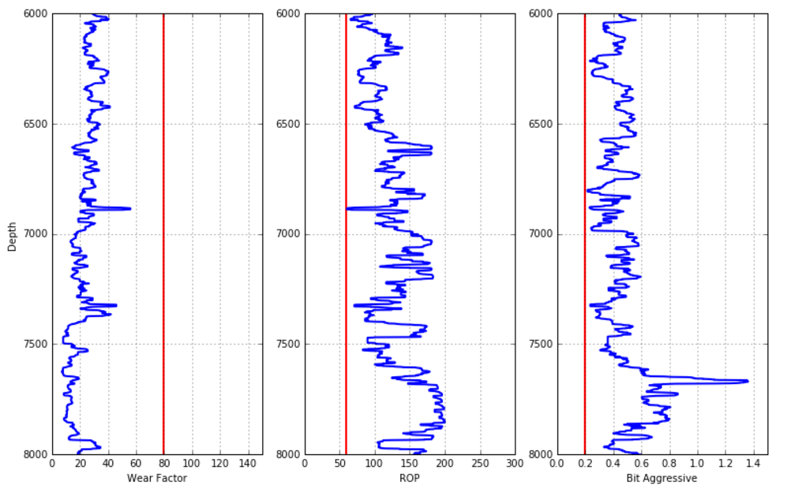

Figure 3 the drilling process from Depth 6000-8000ft

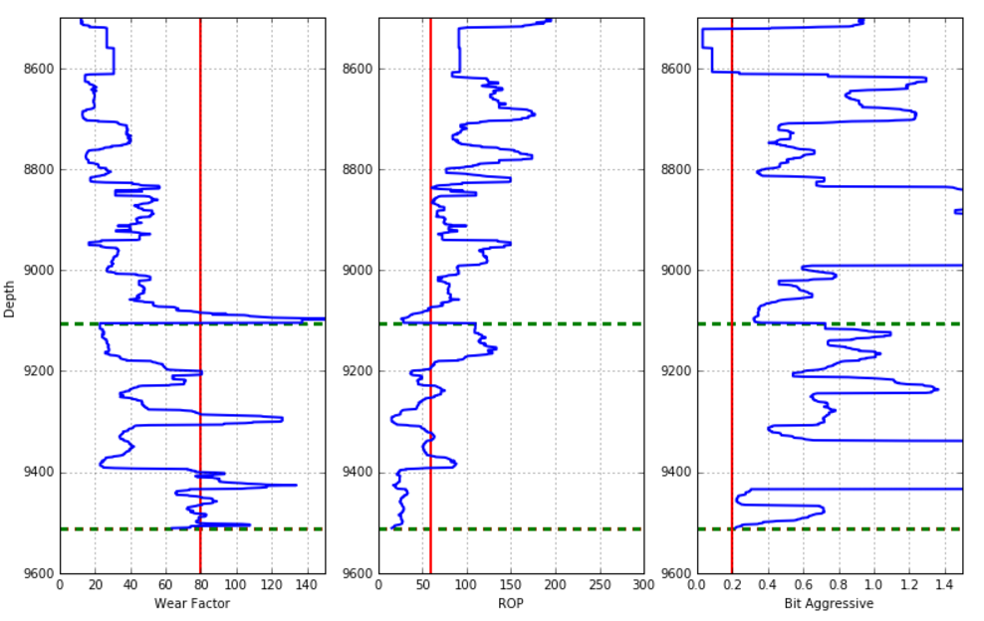

Pull-out

Pull-out

Figure 4 the drilling process from Depth 8500-9600ft. The green dash lines stand for the pull-out depth

**Summary**

|  |  |  |
| --- | --- | --- |
| Pull out events | Interval of warning and pull out (ft) | Pull-out decision |
| 1 | 180 | too late |
| 2 | 50 | right on time |
| 3 | 250 | too late |

We ran the first field test for our software. It detected three potential wear out events based on metrics. The results proved that the algorithms in our software were able to help making better decisions. If the operator can pull out the bit on time after the warning, severe wear out may be avoided. Compared to Wear Out Factor, the Bit Aggressive didn’t give correct warning. The threshold for Bit Aggressive was too low and needed to be improved in the future.

**Part III. Machine learning approach**

The engineering approach is intuitive and easy for implement. However, the bit wear out is a process that gradually evolves over time. Taking the single point as the only criterion will significantly oversimplify the problem. In order to take into account the whole process, a more advanced approach is recommended. In this section, **time series analysis, a statistical learning approach** is used to find patterns and predict the future from the bit condition curves. **Statistical prediction is the art and science of forecasting from data, without knowing in advance what equation one should use.**

Time series analysis has been used widely in operations management, economics, engineering and so on. The bit condition assessment is suitable for time series analysis as the drilling data is expressed in the form of time series. Especially, **autoregressive integrated moving average (ARIMA)** model is used for analysis. In this article, first pull out event and Wear Out Factor were used for illustration.

**Workflow of ARIMA**

**Preprocessing:** the Wear Out Factor is expressed in depth series. It thus needs to be converted to a ‘pseudo’ time series in order to fit into the algorithm. The Figure 5 below shows two depth sections (2000ft-3000ft, 4000ft-5000ft). The 4000-5000ft indicates a positive trend when the drilling bit is about to fail.

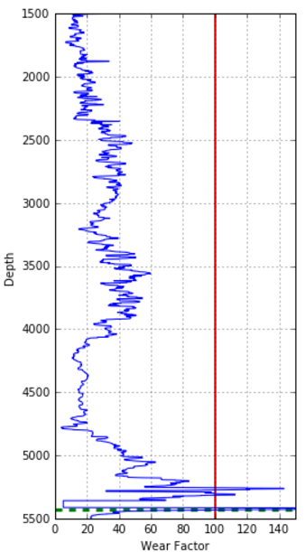 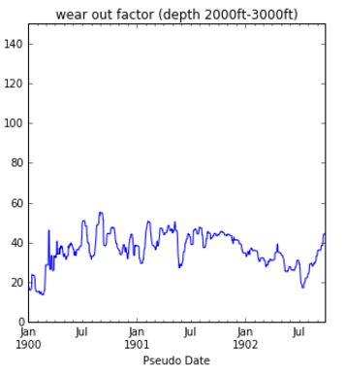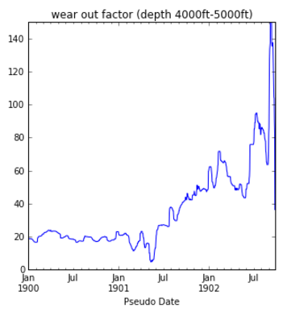

Pull-out

Figure 5 shows two depth section (2000-3000ft, 4000-5000ft).

**Transformations:** The time series analysis requires the data to be stationary. A series is considered as non-stationary if it contains a linear trend or seasonal patterns. First-difference is performed as it can reduce the nonstationary features in the data (Figure 6). Alternative way is to use logarithm.

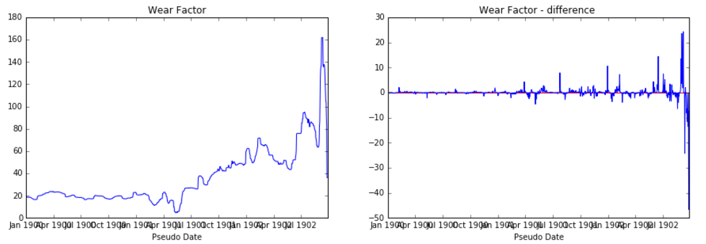

Baseline

Figure 6 (a) original data, (b) first difference data. They oscillate around zero baseline

**ACF and PACF:** The time series analysis predicts the current value based on its past values. The degree of linear correlation between current value and past values is expressed in autocorrelations (ACF) and partial autocorrelations (PACF) (Figure7, 8). The section 2000-3000ft shows no significant lag correlation in either ACF or PACF. One the other hand, in section 4000-5000ft, both ACF and PACF plot have significant value in first few lags.

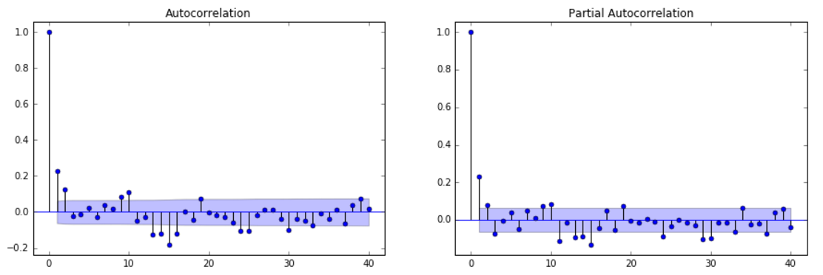

Figure 7 (a) the ACF of the section 2000-3000ft. (b) the PACF of the section 2000-3000ft

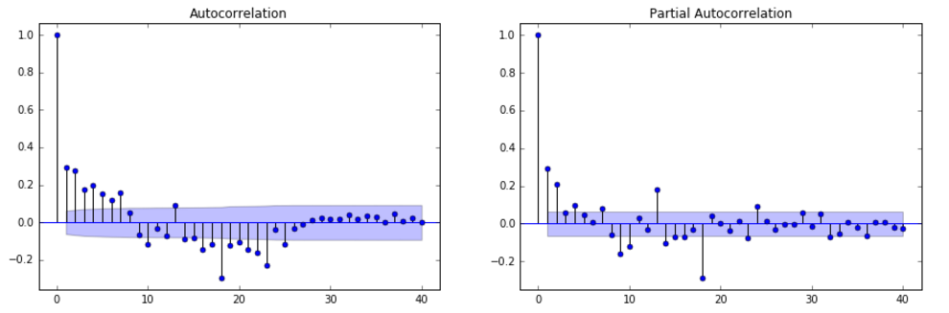

sharp cut

gradual decay

Figure 8 (a) the ACF of the section 4000-5000ft. (b) the PACF of the section 4000-5000ft

**Model Fitting**: The ARIMA(p,q) euqation for predicting y takes the following form: forcast for y at time t = constant + weighted sum of last P values of y + weighted sum of the last forcast errors. The parameters p and q are determined from ACF and PACF plot. In our case(Figure 8 ), the PACF plot cuts off sharply at lag k while there is a more gradual decay in the ACF plot, then we set p=k and q=0. This is a so-called “AR(p) signature.”

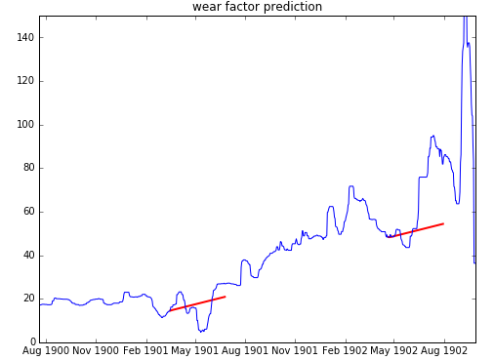

Trend

Abnormal

Figure 9 the prediction results for section 4000-5000ft

**Prediction and abnormal detecting:** Based on the ARIMA model, we make the predictions (red lines in Figure 9). The results show that before wear out, the Wear Out Factor has a mild linear trend. Then this accumulated effect makes the bit enter the wear out stage, where the curve increases dramatically. From Figure 9 all data points at this stage (after second second prediction) are above the prediction line. This abnormal pattern can be used as wear out indication.

In short, the time series analysis can take the whole process into account compared with engineering approach. This approach can also be used in other engineering process such as vibration prediction. More about time series analysis theory can be found at the website of (<http://people.duke.edu/~rnau/411home.htm>). The case study and machine learning code can be found on my Github page.